**Clause Extraction Synopsis**

I have created a basic AI application for extracting clauses/ classes from the pdf at the page level.

The details of the 5 sub folders are as below:

1. **data:**

Contains raw pdf files downloaded from public sources. This folder also contains the code to divide the pdfs into train & test folders for model training and for testing the built solution

1. **ocr:**

Contains the code to extract the text from the pdf files

1. **ml:**

Contains the code: **a)** to generate the training data (csv format at page level) from the text files created from OCR process and, **b)** to train the ML classification model for detecting one of the 4 types [**contract, legistration, public_health, mech_eng**]

1. **new_file:**

Contains the code to make classification prediction on each page of a pdf present in this folder

1. **web-app:**

Contains a basic Django web-application of two pages [upload file, view uploaded files]

Each folder has a readme text file further detailing the contents of those folders.

**Steps to run the end-to-end solution from the main “Clause_Extraction_App” folder:**

1. **[Folder: data] Create the train & test data split from the raw pdf files**
   * Run the commands given in “Clause_Extraction_App/data/readme.txt” to execute the data folder code as shown below

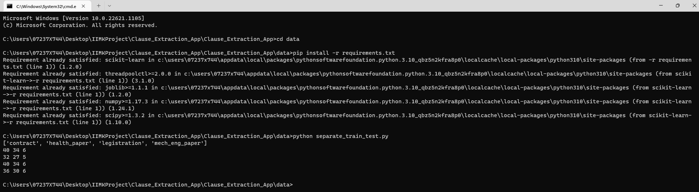

* This would create two folders (train & test) inside data folder as shown below

1. **[Folder: ocr] Extract the text out of the pdfs created in step #1**
   * Download poppler library for pdf handling from <https://github.com/oschwartz10612/poppler-windows/releases/>
   * Download tesseract for windows exe from <https://github.com/UB-Mannheim/tesseract/wiki> and install
   * Change the path to downloaded poppler library bin folder in read_pdf.py file. Also, keep the path of where tesseract has been installed in read_pdf.py (refer below image)

* + Run the commands given in “Clause_Extraction_App/ocr/readme.txt” to execute the ocr folder code as shown below

* + The above code will extract the text (ocr) out of all the files present in train folder of step #1

1. **[Folder: ml] Create the training data and ml model for predicting clause of a pdf page**
   * Run the commands given in “Clause_Extraction_App/ml/readme.txt” to execute the ml folder code as shown below

The below command creates the train.csv file which contains text of each page and the respective clause class to train the ml model

Screenshot of the train.csv:

The below command runs the ml training on the train.csv and creates the models folder containing 2 models:

* **tfidf_vectorizer.joblib**: this model converts the text into vector for ml training
* **clause_clf.joblib**: this is the trained ml model for predicting the clause for the text vectors

models folder:

The above command also displays the results of ML training, for example, in the above cmd screen you can see **the confusion matrix, precision, recall and f1-score** of the training.

Contract, legistration, health and mech are the 4 clause types on which we have trained the ml model.

1. **[Folder: web-app] Web application for user interaction, for uploading contract pdf**
   * Run the commands given in “Clause_Extraction_App/web-app/readme.txt” to execute the web-app folder code as shown below

The above commands run the web server at localhost. To open web app enter <http://localhost:8080/> in browser

Click on “Index new Contracts” to upload your pdf

Now, from the home page (<http://localhost:8080/>) you can click on “See Indexed Contacts” to view the file just uploaded

The file just uploaded is saved inside “\web-app\media\crt_pdfs” folder

This is only a simple we app. In production, the raw pdf files present in the data folder can directly be uploaded through web app by users, instead of downloading from internet

1. **[Folder: new_file] To predict the page level clauses of any pdf file**

We must first save the pdf file in this folder and run the commands given in “Clause_Extraction_App/new_file/readme.txt”. The predict_clause.py uses the pickled files (tfidf_vectorizer.joblib, clause_clf.joblib) created during ml training in step 3.

Change the tesseract and poppler paths in the predict_clause.py as done in step 2

The predict_clause.py file predicted the page level clause for the contract_HNBA-2017-18-Confide.pdf file present inside the folder.

The output is shown on the command prompt as well as saved in out.csv file. As the main file had 4 pages and it was a contract pdf, the output predicts each page of the pdf as contract clause.

**Future Plans:**

**I plan to learn Cloud Application Development soon, so that all the 5 solutions can be deployed on cloud. By deploying this solution on cloud, the application will be available to anyone on internet & these sub-modules can interact with themselves automatically**